⚙ Automatic Zero in Grades
Ensure students see accurate grade calculations by automatically assigning zeros to past due work.

📌 Why Enable Auto Zero for Past Due Work?
✅ Encourages Timely Submissions – Students can immediately see the impact of missing work.
✅ Prevents Misleading Grade Averages – Without auto-zero, Brightspace may calculate grades as if missing work doesn't exist.
✅ Saves Time – No need to manually enter zeros for every late assignment.
✅ Already Default– Can be turned off manually in Grade Settings.

🛠 How to Disable Automatic Zero for Past Due Work in D2L Brightspace

Navigate to Grade Settings
- Go to “Grades” from the course navbar.
- Click the "Settings" button in the upper-right corner.
Disable "Automatic Zero for Missing Submissions"
- In the "Calculation Options" tab, find the setting "Automatically apply a grade of zero (0) to missing submissions once an assessment becomes overdueChanges to this setting only take effect on assessments with future due dates".
- Uncheck this option.
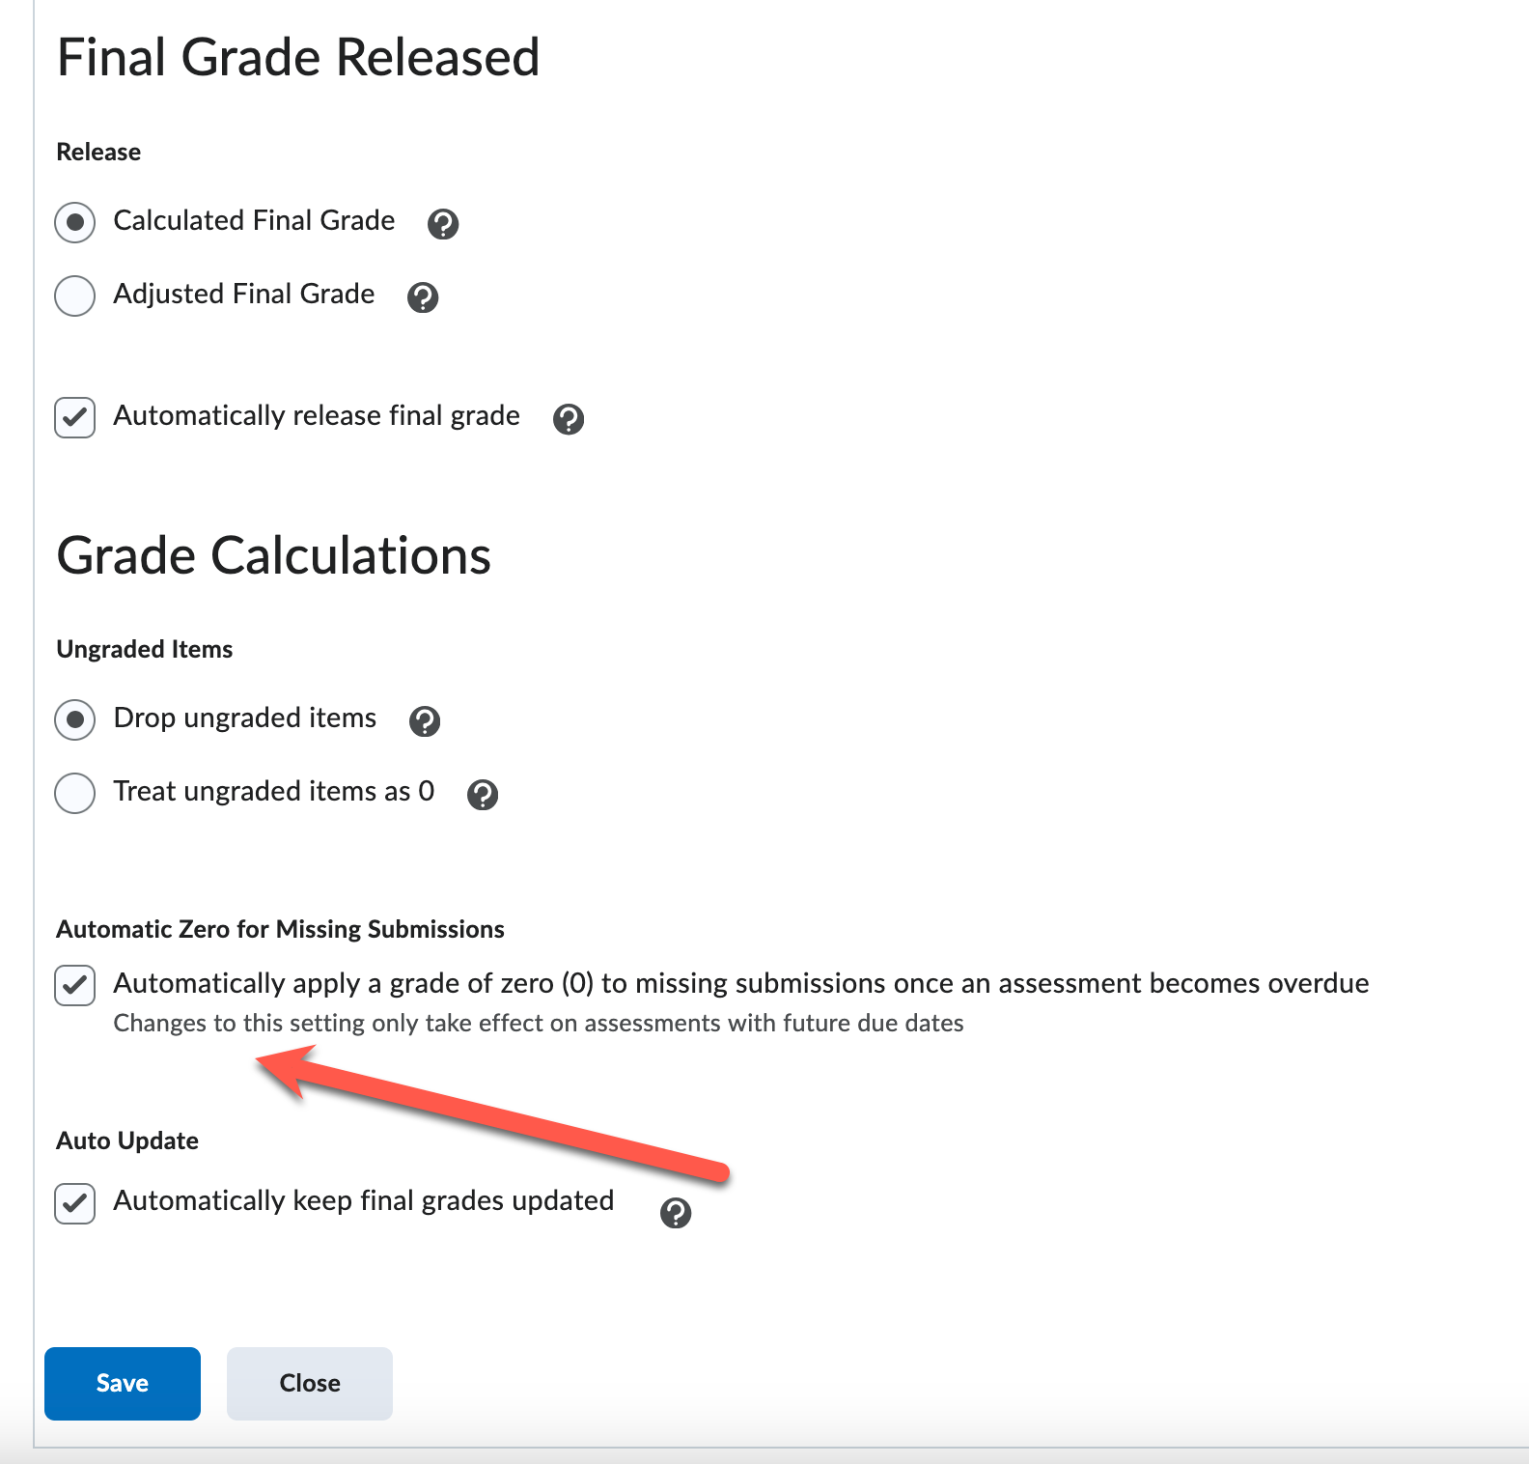
- Click Save and Close.
📌 Effect: All ungraded past-due assignments will count as zero, affecting the student’s overall grade.

Set Automatic Late Policies in Assignments (Optional)
💡 If you want to automatically apply a zero only to past-due work, follow these steps:
- Go to “Assignments” → Click “Edit” on an Assignment.
- Scroll to the “Availability & Conditions” section.
- Set a Due Date and a Late Submission Policy:
  - Example: "Automatically assign a 0 if not submitted by due date."
- Click Save & Close.

💡 Additional Tips & Best Practices
✅ Use Auto Zero + Late Policies – Set a grace period before applying a zero.
✅ Communicate with Students – Let them know missing work will automatically be graded as zero.
✅ Check Student View – Preview how the gradebook looks to ensure transparency.

